Main Topic – Renewables and Natural Gas
Can renewables and natural gas (NG) help one another? I meet regularly with a group of natural gas regulators and technologists whose views of renewable energy vary greatly, not always in a friendly direction. So, I was glad to be asked to address the question at one of their recent meetings.
The short answer, in an electric system planning context anyway, is “yes, because of fundamental economic and technical complementarities.” The appropriate follow up question might be: “Does anybody do electric system planning anymore?” The answer to that one is, “probably somewhere, but in California, not so much.” For more insight on the question and answer, see this issue’s featured blog, “Strategic Planning is Dead?”
The classical planning view would be that in an electric generation mix, higher capital cost/ lower fuel cost generators and higher fuel cost/ lower capital cost generators complement one another, resulting in a least cost generation mix. There are also other complementarities, e.g. overlapping science and technology needs (think enhanced geothermal and natural gas fracking). Likewise, there is a potential at least for shared infrastructure (think injection of bio-methane and later hydrogen from renewable sources into gas pipelines and distribution systems).
So much for simple answers. Let’s dig in a bit. As mentioned in an earlier discussion of net energy, a main premise for thinking about future electricity systems flies under the rather vague banner of “smart grid”. A fully educated grid will introduce an aspect of mutual help between renewables and natural gas beyond optimizing the generation mix. Intelligent infrastructure will mean distributed intelligence, supporting automated decision making and thereby enabling electricity micro-grids and a mix of net positive and net negative end use interconnections.
And let’s also be realistic. Current grid infrastructure is a huge, mostly sunk, cost. Useful infrastructure endures. Our natural gas and electricity grids are essentially permanent features of our energy landscape, where they exist. The important and still somewhat open question is “what will feed in where and how will it be used?”
It is fair, though perhaps controversial, to observe that natural gas and electricity market restructuring intended to apply market pressure downward on fuel costs. Instead it seems to have applied downward pressure on infrastructure investment and even maintenance. Society now faces a fairly large bill for deferred expenditures as it comes to terms with a future requiring more, not less grid resiliency in the face of a gathering storm of locally catastrophic weather events. One foundational and perhaps pervasive element of future grid resiliency will be local mini-grids and micro-grids able to not only operate independently of brittle or fragile regional grids, but also able to purchase, sell and exchange electricity.
But won’t renewable electricity be too expensive relative to electricity from cheap and abundant natural gas? At the well head maybe. But otherwise it is time to close the window on outdated cost forecasts and look instead at market pricing. Remember that we are talking about grids here, and global markets for fuel and renewable energy equipment. These tend to level out the local differences, and it only needs to be mentioned that wind and solar electricity are already at price parity with wholesale and retail grid electricity respectively in this increasingly integrated context. The big “aha!” is that renewable electricity costs have plummeted in recent years while the conventional energy industry’s radar was aimed elsewhere. The result, e.g. best in class installed utility scale solar PV costs finally below the $2000/kW target level set decades ago, have definitely caught the attention of energy finance experts well below the radar screens of most everyone but energy finance experts.
In Europe, the renewable percentage of annual capacity additions is at over 70% and rising. The remainder is mostly natural gas. In the US renewable capacity doubled in the period 2009-2012 while natural gas installed capacity was increasing by 50% in the 2007-2012 period. Global wind capacity reached 282 GW in 2012 while global PV capacity additions leveled off temporarily at 20-25 GW per year since 2010 with double digit growth expected to resume in 2014.
On the core question of whether renewable energy and natural gas can help one another, Europe’s answer is that renewable penetration is rapidly approaching levels that compel attention to the need for flexible generation. The symbiosis between flexible natural gas generation and variable renewable generation is clarified in the recommended reading in the April-May 2013 IRESN Insights. High penetration of variable renewable sources presents a major challenge to current electric systems. The main problem is coping with sudden load ramps, for instant increasing wind generation and reduced demand at the beginning of a weekend and the opposite at the beginning of the week.
The figure (from the referenced Eurelectric report) shows a situation that occurred in Germany in 2009. Exploiting the low variable costs of wind power plants, for example, will not necessarily require more or less utility scale natural gas generation but a different mix. In any event, the economic deployment of wind energy creates a relatively stable and predictable market for natural gas in the power sector, while flexible natural gas generation will enable higher levels of cost effective wind energy grid penetration.
Likewise, the favorable economics of solar PV at the building and community scale will not necessarily require more or less overall natural gas generation. Nevertheless, it may require a mix of natural gas generation more heavily weighted toward distributed natural gas generation. Providing flexibility to accommodate variable renewable electricity feeding in and affecting loadings on distribution circuits can be accomplished in several ways. Distributed natural gas generation currently tops the list, because it relies on mature, proven and well supported products.
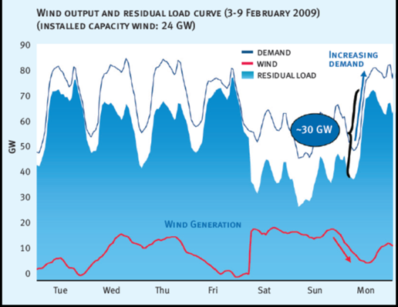
Deployment of solar PV in smaller increments can proceed very rapidly. So, can deployment of flexible distributed natural gas generation, at least in areas where meeting air quality impacts is feasible.
To the surprise and benefit of two as yet unacquainted industries, PV and natural gas distributed generation may widen market windows for one another. The economics of high penetration PV deployment may drive the creation of a relatively stable and predictable market for flexible, utility dispatched natural gas distributed generation (NGDG). On the other side of the coin, NGDG may be a primary enabler of economically desirable levels of cost effective distributed solar electricity production. Deployment of comparable levels of utility dispatched electricity storage will likely be slower to take root. Deployment is more likely to start on the demand side, i.e. in support of demand side management, building owner response to time of use tariffs, etc.
The renewable/NG symbioses discussed above are relatively immediate and urgent in a global context. Also in more local context. For example, on the Hawaiian island of Oahu, rooftop PV deployment, within three years of getting underway, reached levels approaching minimum circuit demand across much of the utility service area. Adding PV capacity beyond this level typically requires special consideration and/or rule changes.
Other symbioses are also opportune but may be farther out on the horizon. For example, thermal solar for heating has considerable traction in Europe and China but lacks appropriate policy attention in the US. Efficient integration of solar and natural gas thermal sources would reduce carbon footprints at the building and community level, but would require attention to design integration and plug and play product packaging opportunities. Likewise, compressed air energy storage is a longer term and lower carbon flexible generation option for electricity grids with high levels of variable renewable penetration.
The full presentation summarized above is posted on the IRESN website. A full report that discusses the information presented in the slides may be developed, subject to sponsor support.

